**SRI LANKA INSTITUTE OF ADVANCED TECHNOLOGICAL EDUCATION**

**(SLIATE)**

**Title**

**BEE STOCK MANAGEMENT** **SYSTEM**

**Group Project Interim Report**

**Group – 07 (Software Track)**

**Supervised by**

**Mr.P.Pirapuraj**

**TEAM MEMBERS**

**S. Katheeskumar (BAT/IT/2018/FT/030)**

**Y. Veanupriyan (BAT/IT/2018/FT/044)**

**HKM. Shaththir (BAT/IT/2018/FT/021)**

**JF. Farhana (BAT/IT/2018/FT/090)**

**MS. Mufasa (BAT/IT/2018/FT/063)**

**Table of Contants**

1. Introduction
2. Background and Motivation
3. Problem Analysis
4. Goals and Objectives
   1. Goals
   2. Objectives
5. Design

5.1 Use-case diagram

5.2 Class diagram

* 1. Component diagram

1. Technology adopted
2. Methodology
3. References

**1. Introduction**

Stock management is the function of understanding the stock mix of a company and the different demands on the stock. The demands are influenced by both external and internal factors and are balanced by the creation of purchase order requests to keep supplies at a reasonable or prescribed level. Stock management is important for every other business enterprise.

This Stock management system is a software which is widely used by retailers, shopkeepers, manufacturing units and other merchants across different businesses. It is used for managing stock of products in their warehouses or in the shops

Information Technology is any computer-based tool used to work with information and support the information –processing needs of an organization. Business will increase their efficiency when they embrace information technology.

Today perfect service is only possible if a business has a right information in the hands of the right people at the right time and this can only occur through the appropriate use of information technology. This means that the challenge facing any business is to plan for, develop, manage, and use its three important resources **Information, Information technology, and people.**

The primary goal of a Stock management is to serve its customers. In this age of information technology, a business can gain the competitive advantage when it uses information technology to its maximum.

**2. Background and motivation**

Our system is about Gone are those days when a shop owner used to manage all his sales and accounts on paper. This job is now performed with these management tools which not only record sales but also notify the retailer about the items low stock.

This project identifies the amount of stock available, the product that is purchased faults in the product, products that are replaced, products that have been sold, and the date at which the products are bought and sold in a particular concern.

Stock manager client web interface component allows the stock manager client to view the current stock of products, along with the capabilities of searching and sorting the products. This system will allow the user to update the stock items during the restocking process.

The cash register client will emulate purchases by having a simple graphical interface with fields for a quantity and a button to make a purchase

The main objective of this Bee Business Organization project stock management system is to overcome the work load and time consumption which makes the maintenance of the stock in an organization as a tedious process. This project provides complete information about the details of the stock to the users. Separate modules have been created for purchasing, viewing stock details, selling details and delivery details. As a whole, marketing process can be improved if stock has been maintained properly.

**3. Problems Analysis**

Every company needs to keep detailed records in order to maintain normal and efficient operations. Company can keep up with a growing client base and adjust to changes. In a growing business, change is inevitable over time and businesses need to be able to fluctuate. Poor records can lead to damaged business relationships and delays in virtually every department in the company from day-to-day operations to accounting and human resources. The automated system is the low cost of doing business, but using manual data entry system mean more personal will be engaged to increase service delivery and each member of the workforce must be trained to meet the basic standard required to perform assigned tasks.

* 1. **Lack of security**

Paper document filing can be less secure than electronic filing systems. Misplaced documents can easily be placed in the wrong hands. Clients expect their information to be secure in your hands. If you can’t keep this safe, you are at risk for losing them

* 1. **Access time**

Manual document filing is very time consuming. Not only do you have to organize and store the files, hunting down the information when it is need can take time

**3.3 Poor Communication**

A manager expects the item to still be available for customer during a sale. Compared with a computerize stock system, a manual stock system does not help the communication in the workplace

**3.4 Difficult Ordering Supplies**

Does not update at the end of the day with updated stock counts. You must go through the stock items each time you need to place an order for new raw materials, products or supplies for the stock So keeping track of Ordering supplies is another difficult

**4. Goals & Objectives**

**4.1 Goal**

Stock management is essential for a business to succeed. Good management of your organization’s stock decreases excess inventory and ensures that you have enough product on hand to meet customer demand. Develop a Stock management plan to streamline ordering and reduce wasted time on inventory control.

* 1. **Objective**

The objectives of stock management are to provide the desired level of customer service, to allow cost-efficient operations, and to minimize the inventory investment

* To facilitate furnishing of data for short term and long-term planning and control of inventory.
* improve an organization business service
* Help the store keeper with management information.
* It helps to check whether stock is available or not

**5.Designs**

**5.1 Class Diagram**

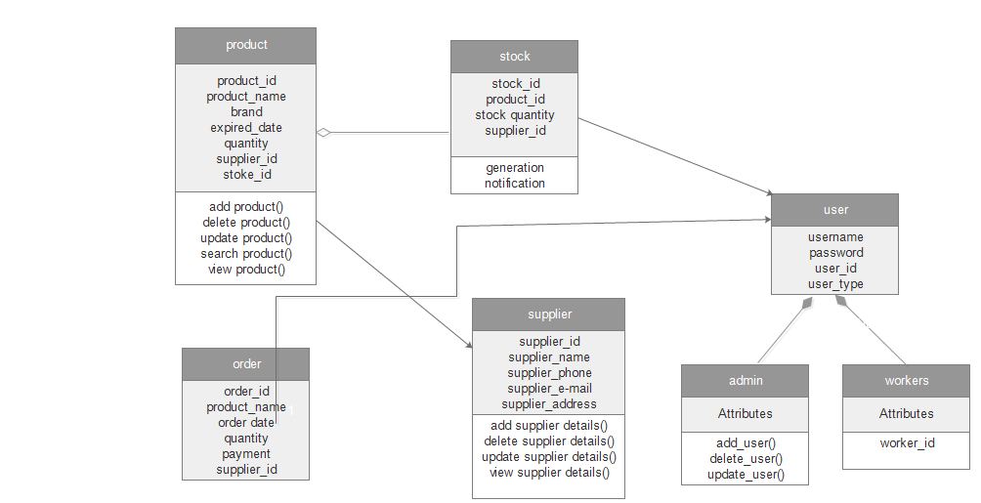

**5.1 Component Diagram**

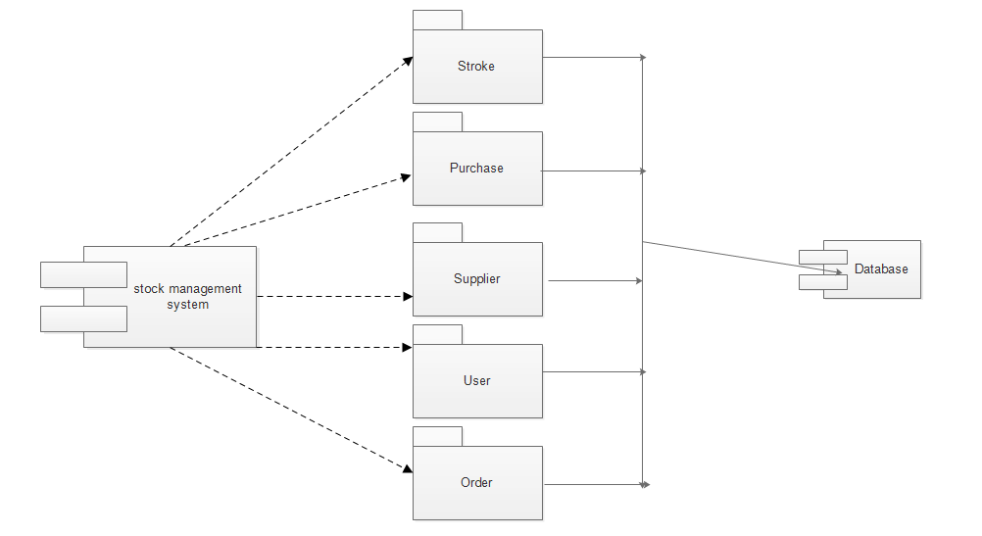

* 1. **Use Case Diagram**

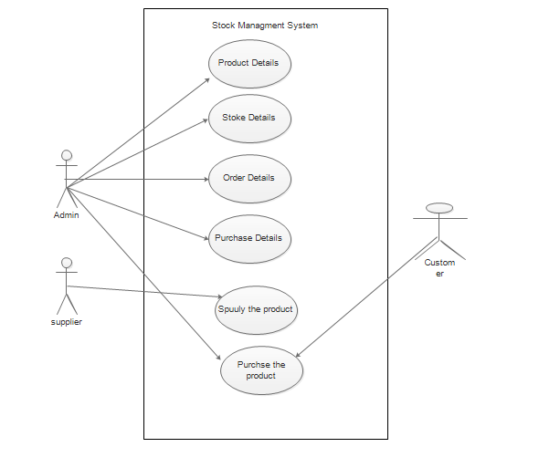

**6. Technology Adopted**

The technologies we have adopted so far for the development of software and the technologies that we will be undertaking in the future. Technologies have been used in our project given below.

**PHP**

PHP is a server-side scripting language designed for web development but also used as a general-purpose programming language. PHP is used to save the keyboard input to the database and retrieve by filtering.

**Java script**

An extension for Google Chrome browser is developed using Java script. JavaScript (JS) is a dynamic computer programming language. It is most commonly used as part of web browsers, whose implementations allow client-side scripts to interact with the user, control the browser, communicate asynchronously, and alter the document content that is displayed. Hence, Java script is used to develop the extension.

**MySQL**

MySQL is a relational database management system (DBMS), and can be used to create and manage MySQL databases, build database structures, back up data, inspect status, and work with data records. The database to store input is built using MySQL.

**7. Methodology**

In order to accomplish this, first a user is given a discussion topic to be referred. Bee Stock Management System platform if used for this. After user engaged and replied for the post his/her answer are evaluated using following parameters.

In order to have broader source or rating all the users discuss about the future developed system on discussion topics. Also at the end of the lesson, system is provides an update stock details regarding the user/admin. User can order or update their purchasing details & admin can update their stock details.

**8.References**

<https://www.electronjs.org>

<https://www.laravel.com>

<https://www.stackoverflow.com>